

Kungliga Tekniska Högskolan

**MF2104 HT22 Mechatronics for Product Design**

**Group 3: Magical Origami**

*Submitted by:*

**Hala Mawas**

**Yawen D**

**Rimmie Duraisamy**

**Atocha Anaya**

Table of Contents

Introduction 3

Scope 3

Background 3

Final concept for the Winch system 3

Bearings 4

Analytical model 17

Finite Element Analysis 19

**Loads and boundary conditions** 19

FEA results for chain link 19

Mesh convergence study 22

Fatigue and Life prediction 23

Fatigue life assessment of the link 24

Durability of Elastomeric Bearing 24

Prototyping 25

Test Procedure 28

Experiment results 29

Correlating experiment and analytical model 31

Conclusions and discussion 31

Future Work 32

# Introduction

Electricity generation has to meet the growing demand of energy as well as lower emissions of CO2. To meet these strict requirements, focus has been directed to renewable energy sources - one being wave energy. It is a largely unexploited form of renewable energy that can contribute to approximately 10 percent of the world’s energy demand.

One way of harvesting wave energy is with a wave energy point absorber. The concept is that a buoy, at the surface of the water, is moved up and down by the ocean waves. A power take-off unit (PTO) utilizes the periodic motion of the waves to generate electricity. PTO systems are generally linear devices, which require end stops to limit the movement. During storms, very large forces can occur due to the stopping action of these end stops.

Rather than dimensioning the whole structure to handle these large forces, a winch-based PTO can be used. This allows for creating a much larger stroke length so that no end stops are present, reducing the forces on the overall system.

# Scope

The purpose of this project is to develop a durable winch system for a wave energy point absorber. The chain concept developed in the previous half of the project will be analyzed and further optimized, ensuring that it can hold for the maximum force of 200 kN and have a life expectancy of 20 years, or 80 million load cycles. A detailed design, followed by a physical prototype of a chain link including bearings will be done. A test rig will also be designed and manufactured in order to test the bearing and validate the analytical method used. Only conceptual designs of the winch alignment system will be presented due to the time limitation of this project. The pretensioning system and the generator are out of scope.

# Background

As part of Machine Design Advanced Course I, a preliminary literature study and patent search was done at the start of the project. Following which new concepts were generated for the chain/rope for the winch system. Thorough evaluation of the concepts using Pugh matrix provided the most promising and optimal concept. This report details the complete design and development of the final selected concept from the previous course. The following sections elaborates the final solution for the winch system which encompases analytical modelling, finite element analysis and fatigue life assessment.

# Final concept for the Winch system

A detailed study was carried out to find a solution to avoid wear between pin and link, none of the identified existing solutions could extend the life of the chain to 20 years or to make it function for 80 million loading cycles in marine environment. Bearing was the crucial part of the problem statement and played an important role in preventing the wear between pin and link. Some of the existing bearing solutions analysed are presented in the following section.

# Bearings

One of the main objective in this project was to investigate on a suitable bearing for link and pin, which has to prevent wear between link and pin lasting for 20 years of operating life and 80 million loading cycles.

A detailed study was conducted on the existing composite sliding bearings from various companies but the life of these bearing was not to the desired level. Some of the bearings that were analysed are SKF Filament wound bearings and Trelleborg Orkot sliding bearings.

**SKF Filament wound bearings**

SKF filament wound bushings are an excellent solution for applications where there are heavy loads, strong vibrations and corrosive environments. They have a permissible load rating of 140 N/mm^2 but the allowable sliding velocity is really low.

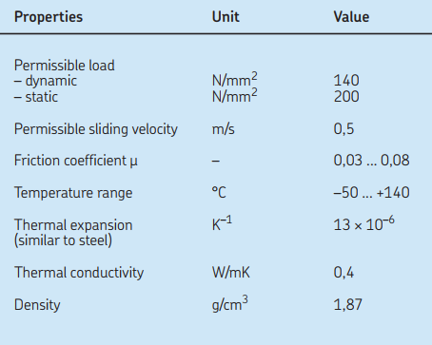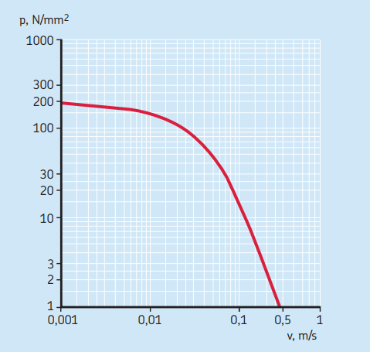

The sliding velocity between link and pin calculated to be around 0.03 m/s and the pressure is 110 MPa. Even though the SKF bearing just qualifies the limit it is not recommended by the company to operate at that pressure continuously and the recommended value is around 80 MPa with life expectancy of one million cycles. Hence we concluded that this cannot be a potential solution.

**Trelleborg Orkot bearings**

The second option was Trelleborgs Orkot bearing. Trelleborg claims that if the bearing pressure is lower than 10 % of the maximum pressure and if the cyclic loading is well below 100 Hz, the fatigue of the material will not be a problem since the material will have time to react to the cyclic loading and dissipate the heat. Thus wear between the pin and the link will be the deciding factor.

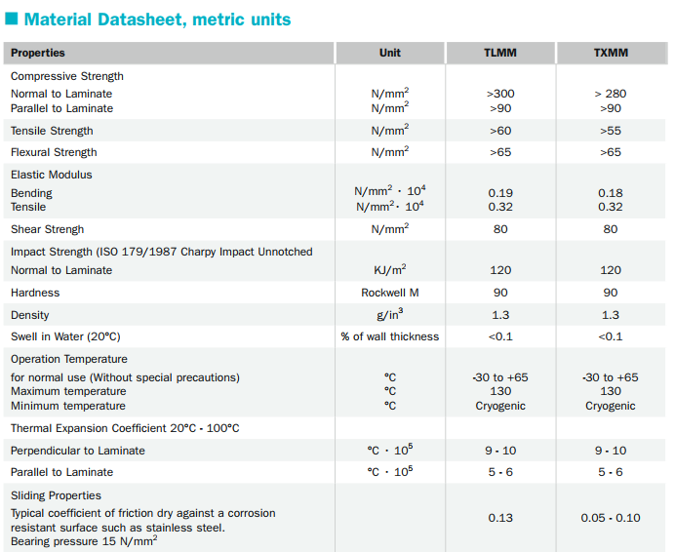

The bearing was designed for a bearing pressure of 78 MPa for the highest load case, assuming the following load distribution:

**Forces Distribution**

10 kN 65 %  
30 kN 32 %  
100 kN 3 %

Choosing TXMM grade Orkot with the following dimensions.



Allowing for 1 mm of wear across the force distribution gave the following sliding distances for 10, 30 and 100 kN respectively:

**Forces Sliding distance**

10 kN 59500 m  
30 kN 19850 m  
100 kN 5950 m

This would equate to a total allowed sliding distance of 31165 m. Assuming that 10 load cycles per minute occur with a radial deformation of +-10 degrees, a total of roughly 5 million load cycles is the life of the bearing making it quite much lower than required life of the chain.

Once verifying the existing solutions and learning that they cannot provide the desired life time, a solution was developed to completely take out sliding action between pin and link making the in between region elastic and rigid at the same time in different direction. The solution is Elastomeric bearing, which can take huge amount of compressive loads and at the same time be flexible in the shear direction. The detailed explanation of elastomeric bearing is described below.

**Elastomeric bearing**

The elastomeric bearing are alternate layers of elastomers and steel shims bonded together by a process called vulcanization. It is a chemical process for converting natural rubber or related polymers into more durable materials by the addition of sulfur or other equivalent curatives or accelerators. Dramatic increase in compressive modulus of an elastomer as their shape factor increase make them capable to bear huge amount of compressive load and elastomer being elastic in nature can flex in the shear direction within certain limits.

Design of elastomeric bearing or elastomer in general is mainly dependent on the shape factor of the body. The shape factor is defined as the ratio of loaded area to unloaded area or free area. see figure xxx

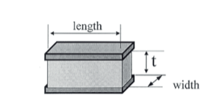

If a normal vertical load is applied for the component in the figure shown above, then shape factor for such a component is given as

Shape factor(S) = loaded area /unloaded area

S=(Length * width)/(2*(Length+width)*t)

The variation of compressive modulus as the shape factor increases is given in the figure xxx and can be seen clearly that as the shape factor of the elastomer increases the compressive modulus increases in a nonlinear fashion.

The relation between shape factor and altered compressive young’s modulus is given as

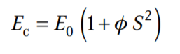

where

Ec= Altered compressive modulus in N/mm2

Eo= Original compressive modulus in N/mm2

S= Shape factor

Ø=Elastomer compression coefficient.

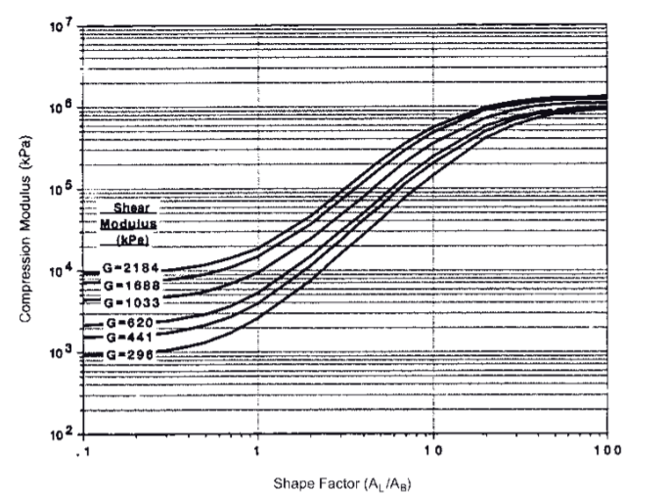

It must be noted that as the compressive load is applied there will be a strain induced in the elastomeric bearing which results in variation of shear modulus of the elastomer material and the variation can be described as shown in figurexxx and is also dependent on the shape factor.

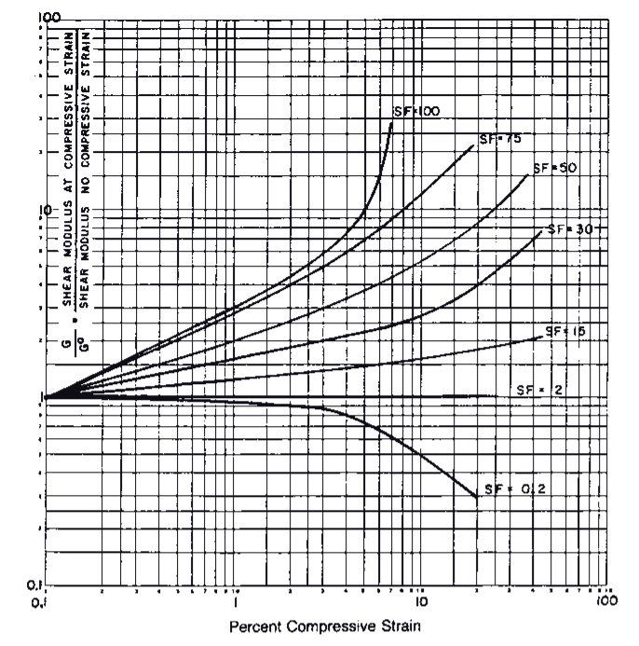

The final concept of elastomeric bearing design includes all the above considerations. The maximum load taken by large link is 100 kN, this decides the thickness of the elastomer layer. In other words gives an idea of what should be the shape factor for the elastomer layer. The analytical model combined with math code explains clearly about the formulations involved to calculate the shape factor to keep the strain within 10 percent.

Once the shape factor is decided the next step towards design is to determine the number of layers in the elastomeric bearings which is decided from the required shear stiffness and also from the angular deformation it should undergo. The maximum angular deformation in this case is estimated to be around 10 degrees however the operating range does not exceed 5 degrees. The formulations to compute the compressive stiffness and shear stiffness for the elastomeric bearing is given as follows.

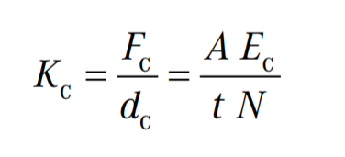

where

Kc = Compression spring rate

N = number of identical elastomer layers

t = individual layer thickness

Ec = individual layer compression modulus

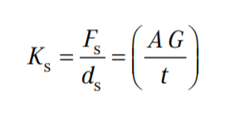

where

Ks = shear spring rate

Fs = applied force in the shear direction

ds = shear displacement

A = load area

G = shear modulus

t = total thickness of elastomer

The final elastomeric bearing (figure xxx) has total 7 layers, 3 layers of stainless steel and 4 layers of elastomer, each layer being 1 mm thick. The properties of the elastomer is as follows

Original Young’s modulus Eo= 9.239 MPa

Original Shear modulus Go= 2.186 MPa.

Material Compressibility coefficient = 0.52

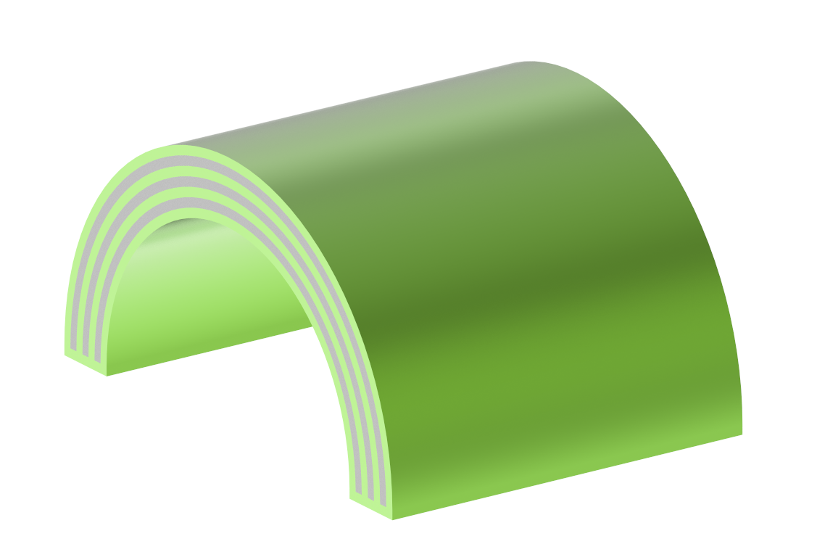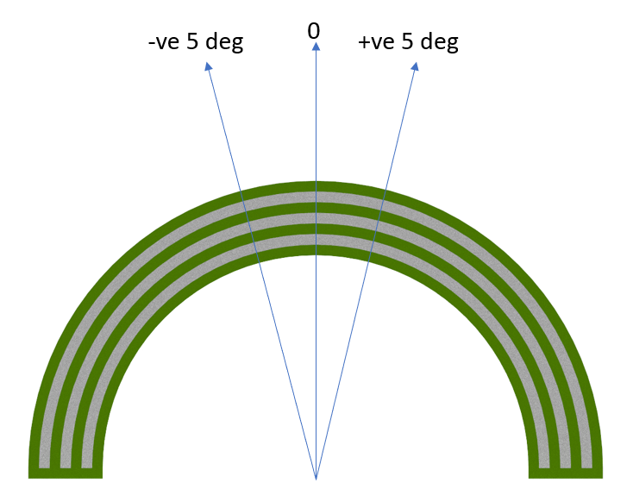

**Thickness of steel shims:**

The thickness of the steel shims to be used in the elastomeric bearing is decided based on two types of formulation i.e. service limit state and fatigue limit state, as the name itself suggests they are based on the service maximum compressive load and average compressive loads.

Service limit state:

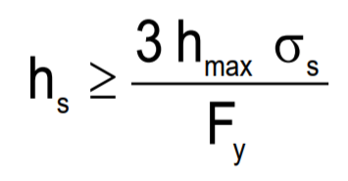

Fatigue limit state:

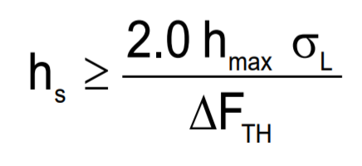

where:

hs = Thickness of the steel reinforcement (mm)

hmax = Thickness of the thickest elastomeric layer in elastomeric bearing(mm)

σ s = Service average compressive stress due to total load (Mpa)

Fy = Yield strength of steel reinforcement (Mpa)

L = Service average compressive stress due to live load (Mpa)

∆FTH = Constant amplitude fatigue threshold (Mpa)

The maximum bearing pressure was fixed to be 110 Mpa and sheet being duplex stainless steel, the yield strength is around 460 Mpa which gives us a thickness value of 0.717 mm. The fatigue limit state gives a thickness value even less than the previous value. Hence, the steel shim thickness was decided to be 1 mm, since it is a standard thickness available in the form of sheet:

**Duplex steel:**

Duplex stainless steel was chosen as the material for the link, pin and drum since it is highly resistant to corrosion, also its yield strength and fatigue strength is higher than normal steel. It is a type of stainless steel which combines a austenitic and ferritic structure. The combination of these two structures gives it both good properties that are related to both ferrite and austenite. It is used in very corrosive environments, without the need for painting, like pressure piping for seawater, chemicals, gas and oil handling. It is mainly used offshore applications and at oil refineries. For example 2205 (EN 1.4462) has a PRE number of 35 which show a good resistance to corrosion. The material properties for duplex 2205 can be found in table xxx.

|  |  |  |  |  |  |
| --- | --- | --- | --- | --- | --- |
| **Grade** | **Tensile Strength (MPa)** | **Yield Strength (MPa)** | **Brinell hardness**  **(HB)** | **Density**  **(kg/m3)** | **Elasticity Modulus (GPa)** |
| 2205 | 621 | 448 | 293 | 782 | 190 |

**Link:**

The link was designed based on two aspects, primarily to maintain minimum number of joints in the chain and the other one was to have a maximum possible relative angle between the links when rolled up over the drum in order to effectively utilize the flexing property of the elastomeric bearing. The detailed strength analysis of the link is explained in analytical and finite element section.

Topology optimisation of the link was carried out in order to increase the strength to weight ratio and the same is shown in the figure xxx. An objective was set to minimise the compliance for a load case of 100 kN with two response constraint one was to reduce the volume by 50 percent and to maintain the global Von Mises stress within 300 Mpa.

A specific cut out was given to both the ends of link in order to locate the elastomeric bearing in place and partially prevent the possible sliding motion of the outer layer if there is any breakage of bond with the link. The cut out includes the geometry of the elastomeric bearing in upper hemisphere and pin geometry in the lower hemisphere with a clearance of 3 mm so that when the chain is wound over the drum the link has that degree of freedom to have relative angle b/w previous link in a plane tangential to drum surface. The top and bottom surface of the link were given a radius of curvature to maintain a conformal contact with the drum surface.

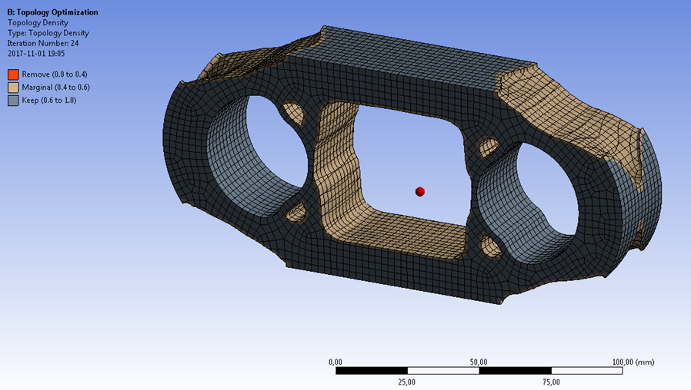

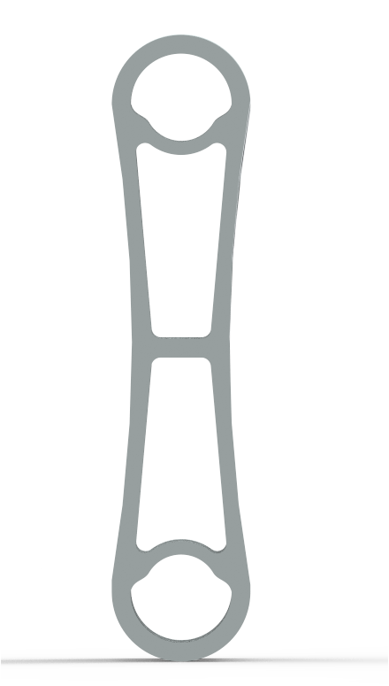

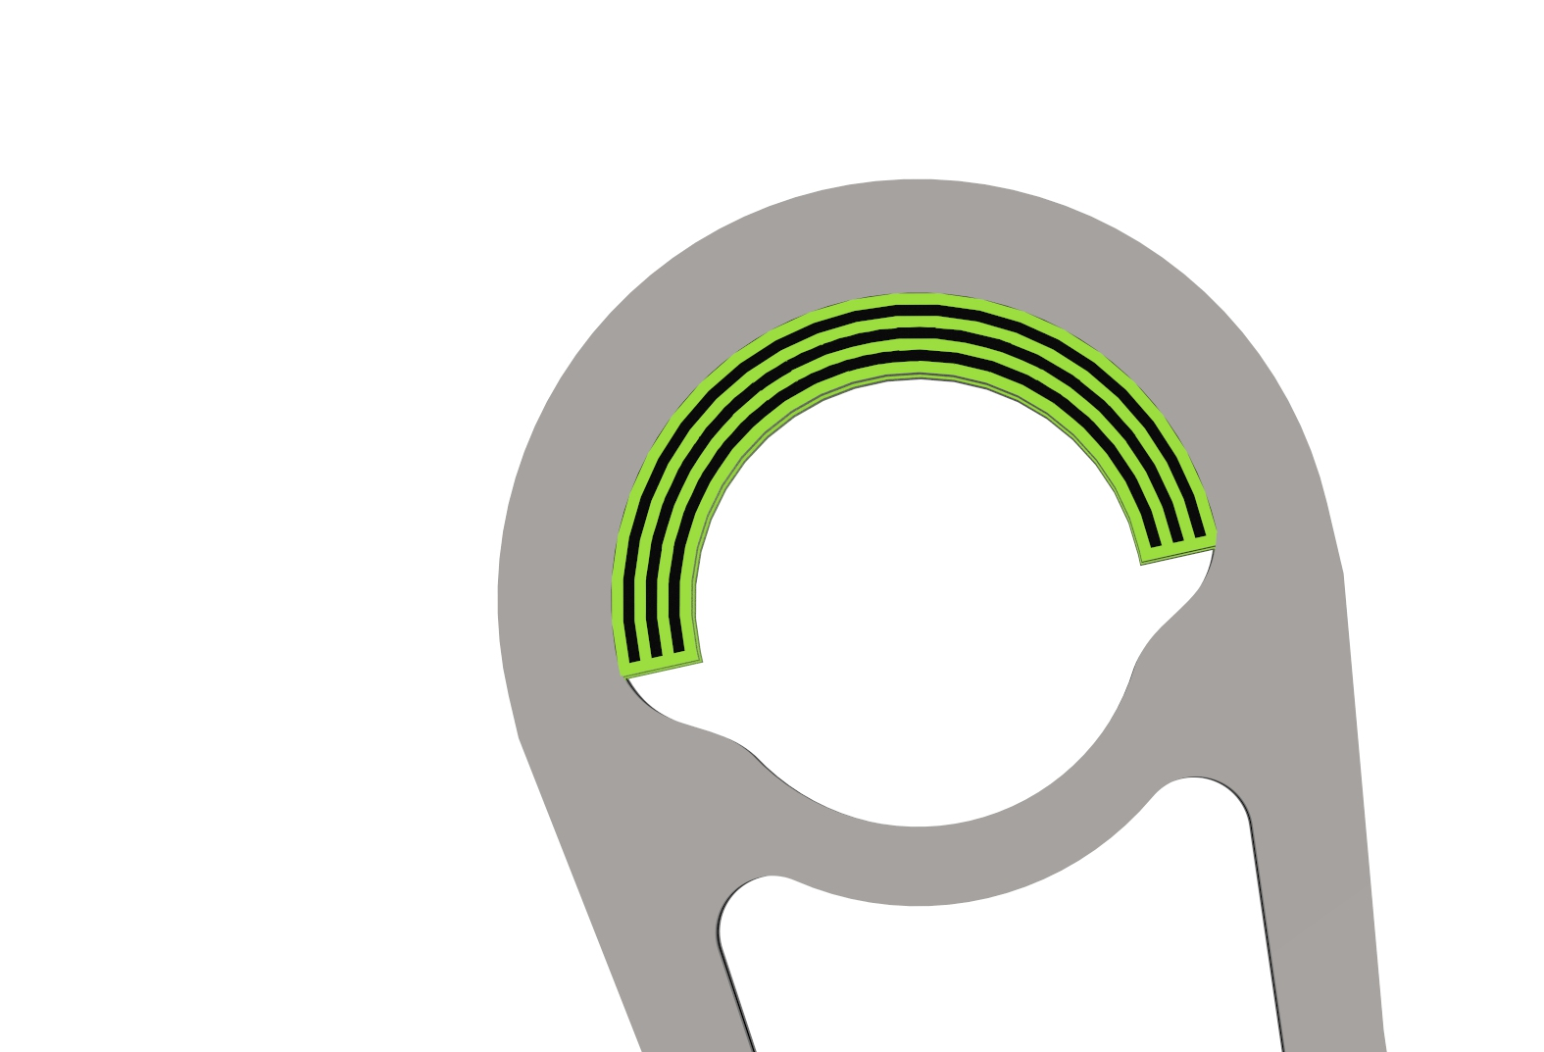

The overall width of the chain is 200 mm and two angles are important when it is required to roll the chain over the drum in a spiral way, one is the helix angle and the other is side angle required to deviate the link set sideways w.r.t its previous link set in order to take the path in a spiral way. see figure xxx. alpha is the helix angle required to achieve the required pitch and beta is the side relative angle between two consecutive link set in a plane tangential to the drum surface. This requires a clearance beneath the pin of every link set to have that degree of freedom. figure xxx

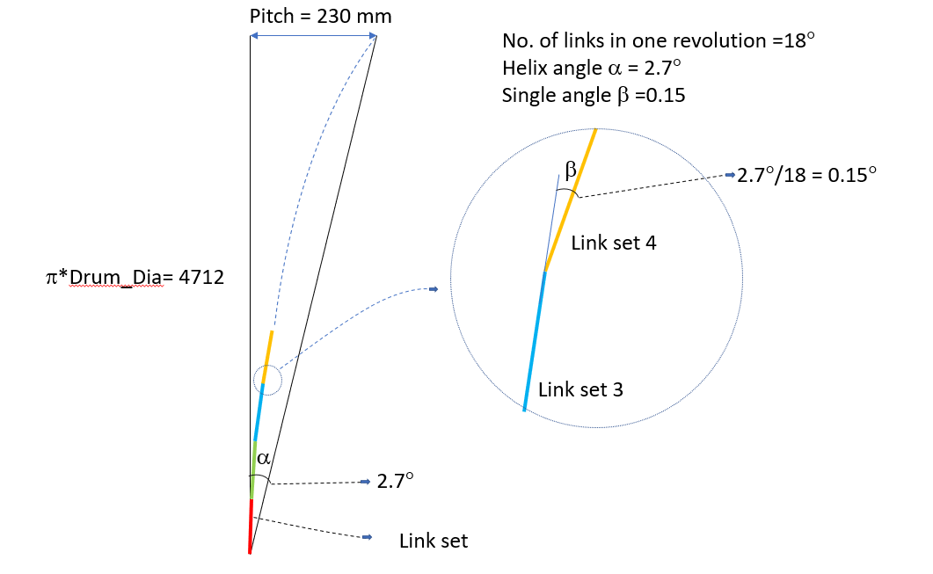

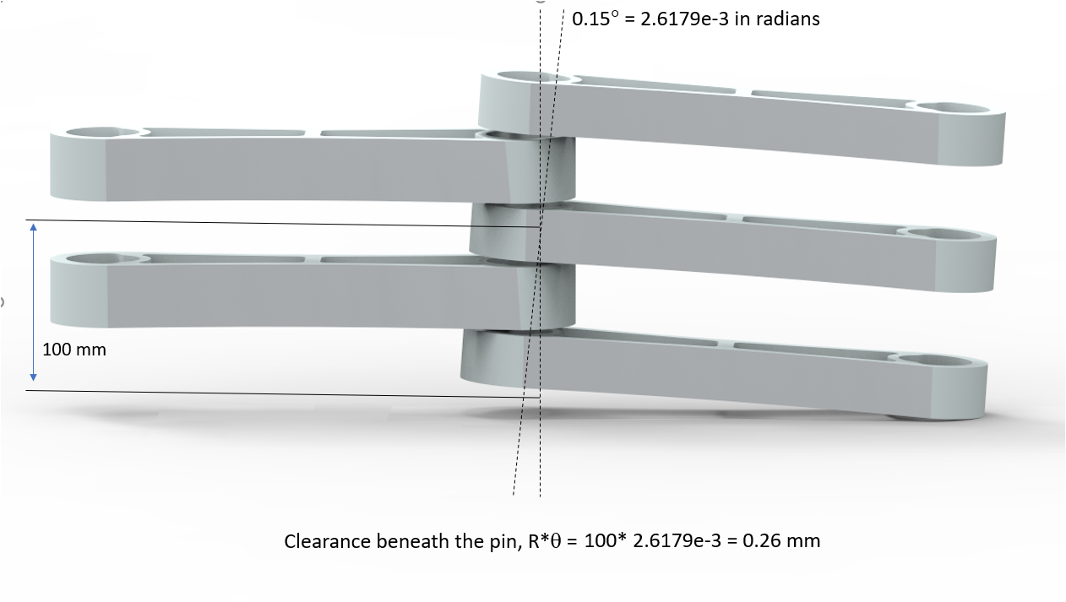

**Drum**

The drum will operate in a harsh environment due to the alternating high forces from the chain and aswell the saltwater. It has been designed in order the withstand these forces as well as being cheap and lightweight.

When considering the design of the drum it is desirable to make it as light as possible and to keep the manufacturing costs low. When comparing a casted, turned and welded drum all of these have some advantages and disadvantages. A casted drum design would be pretty easy to manufacture but the disadvantages makes it quite unreliable. When considering casting, one will get a porosity and therefore will the material thickness be bigger than comparing with a welded drum. A casted design would demand a shaft that goes through the whole drum which will add to weight and cost. If considering a turned drum, the advantage is that it’s simple to manufacture with good tolerances but the disadvantages are more. When turning a cylinder into the dimensions needed a lot of material will need to be removed. It will be hard to reach into the center of the drum to remove some excess weight therefore making this design too heavy. The welded drum design would combine turning for the shaft where the bearings will be seated and use plates that has been formed into pipes and welded along the pipe. This design will have to consider some more advanced stress calculations but will be cheaper in the end. Therefore was a welded drum the design to develop further.

The drum consists of two end shafts that are welded together with two disks on each side which connects the drum and shaft, as can be seen in fig x.x. To avoid the potential buckling of the disks, 4 stiffeners are welded in between the disks as can be seen as a cut view below in fig x.x. The welds in between the disk and the drum as well in between the disk and the shafts will transfer the torsional forces from the drum to the shaft.

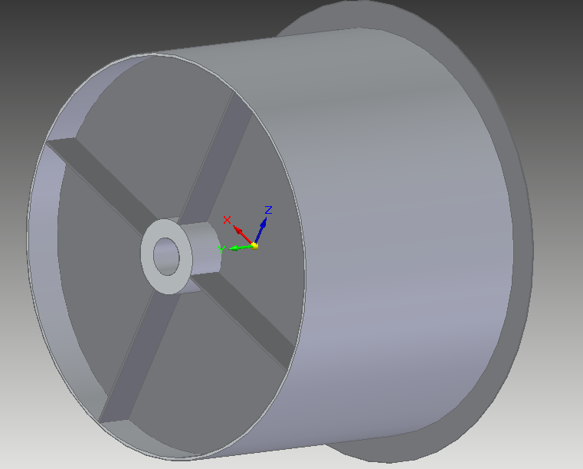

When considering materials it will have to be weldable, have a low wear coefficient and should withstand corrosive environments. The material that matches this application without having to be a special or rare type of metal which often add a lot on costs is a duplex steel 2205 (EN 1.4462) since it’s very hard and is very corrosion- and wear resistant. The shaft ends are hollow to reduce weight and use as much of the material as possible. The shaft ends will be turned in order to get a good fit for the bearings. The sides will be cut out from a 15mm plate and will be welded to the shaft ends and the cylinder (drum) with but welds. The drum will be manufactured by using a plate that is rolled into a pipe or by buying a pipe in these dimensions. The dimensions shown in fig X.1 has been designed to make the chain fit onto the drum without overlapping itself and to withstand the dynamic forces presented. The calculated dimensions for the drum and bearings can be seen in appendix A. The forces that is acting on the welds are mostly shear stress and since the bending stresses affecting the welds are less than 10% of the shear stress we can neglect the bending stresses (Clas Olsson, Konstruktionshandbok för svetsade produkter i stål, januari 2014) which makes this a much simpler case to calculate.

The a-measurement of the welds are of importance to make sure that the drum can withstand the force spectrum. In this case a statical and a dynamical calculation has been performed. First of one has to make sure that these weld will be able to withstand a static worst case of 200 kN. 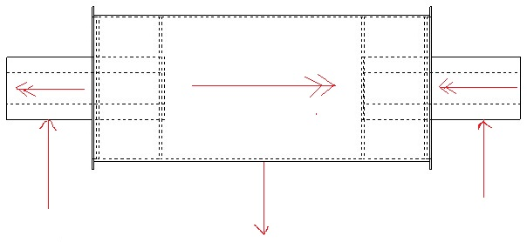

The effective weld length between the drum and the discs and the effective length between the shaft ends and the discs are calculated according to eq. x.1

$$Ø=πd$$

which gives an effective weld length of about di = 880 mm (between shaft and disc) and do = 4712 mm (between drum and disc). The torque at the center of the drum and the shaft ends are;

$T=F\frac{d}{2}$,

To = 150000 Nm (torque over drum) and Ti = 75000 Nm (torque at shaft ends). Since the bending forces can be neglected in this case we will not consider them. When calculating the static case we have to take two equations into account;

$τ_{||}=\frac{F_{||}γ_{n}γ_{F}}{A_{w}}$ and, $3\sqrt{τ}≤\frac{f_{wuk}}{β_{w}γ_{M2}}$.

Where $τ$ is shear stress in the weld, F is the force acting along the weld, $γ_{n}$ is a consequence factor, $γ_{F}$ is a load factor, $A_{w}$ is the area of the weld as a cut section, $f_{wuk}$ is the ultimate strength of the weld material, $β_{w}$ is a material constant and $γ_{M2}$ is also a material constant. With the load factor set to 1,1, the consequence factor set to 1,25, the material constants both set to 1,0 and knowing that the ultimate strength for the weld would be 800 MPa and the area of the weld consists of the a-measurement and the effective length we can easily calculate the needed a-measurement.

$$a=\frac{F_{||}γ_{n}γ_{F}}{τ_{||}l_{eff}}$$

Which gives us a measurement of way below 3 mm which is the least you should have according to SS-EN ISO 1011.

When calculating the dynamic case, the material doesn’t matter it is all about the geometry and weld class. In this case the weld will experience shear stress which will give us FAT 80. These values can be found in fig x.2.



From fig x.3 and eq. X.5 (Claes olsson, Konstruktionshandbok för svetsade produkter i stål, januari 2014) we can calculate the maximum stress to be able to withstand 80 million revolutions.

$${Δτ}_{||}= {\left(\frac{2}{10}\right)}^{\left(\frac{1}{5}-\frac{1}{22}\right)}FAT{\left(\frac{2*{10}^{6}}{80*{10}^{6}}\right)}^{\frac{1}{22}}$$

Since we got FAT 80 we will get a maximum shear stress of about 52,75 MPa that can be rounded up to 52 MPa. With eq. X.4 and eq. X.5 we will get a a-measurement of 4 mm between the shaft end and the disc and a a-measurement of 1,73 mm between the drum and the disc. Since any measurement under 3 mm isn’t acceptable according to SS-EN ISO 1011 and that it is possible to get a a-measurement with one weld to 5 mm we will set both of these welds to 5 mm. This will add some extra safety and will not add too much weight or costs. The only thing that should be considered in this case is how the warmth of the welding process will affect the material. Annealing would be considered even when using smaller welds in order to get a higher security against failure. The welds between the drum and the edge rim will not be affected but any forces of significance these will not have to be calculated and will be butt welded to avoid crevice corrosion. The weldings can be seen in figure x.4.

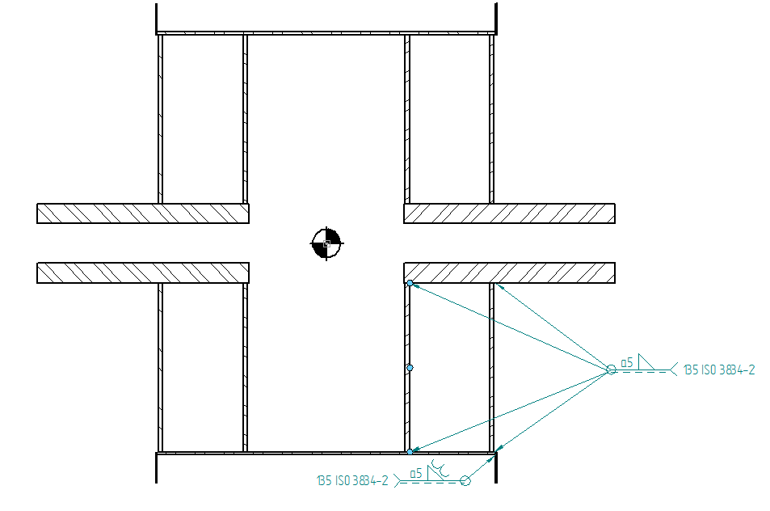

Since this is a dynamically affected application and that repairing it is harder offshore the weld class will be B according to ISO 5817 and done according to at least ISO 3834-2 which is the highest class of welds.

Analytical model of the drum

The shaft have a hollow design to reduce material and weight. The inner diameter is 50% of the outer diameter that was first calculated with the von mises criteria giving it a outer diameter of approximately 220 mm with a safety factor of 1,3. But in order to design the shaft to fit with a proper bearing, the final outer diameter was chosen to 280 mm due to the size of the bearing. The life expectancy of the bearing is calculated according to SKF’s standards using eq. x.x below,

$L10 = {(\frac{C}{P})}^{\frac{10}{3}}$ eq. x.x

where L10 is million revolutions, C is a load coefficient and P is the force acting on the bearing. The Force P was set to the maximum force to get a good safety to wear.

The size of the drum was restricted by the chain making it 1,5 m in diameter to avoid too much torsional loads in the bearings. The thickness was then set to 10 mm with eq. x.x below

$τ = \frac{M_{v}}{W_{v}}$ eq. x.x

where Wv is,

$W_{v} = \frac{πD^{2}t}{2}$ eq. x.x

and Mv is,

$M_{v} = \frac{2P}{D}$ eq. x.x.

$τ$ was set to the yield strength of duplex steel with a safety factor of way over 5. The discs connecting the shaft to the drum is made of 15 mm and the stiffeners of 10 mm both of duplex steel. To validate the stresses in the drum, FEA calculations was made and figures are shown below.

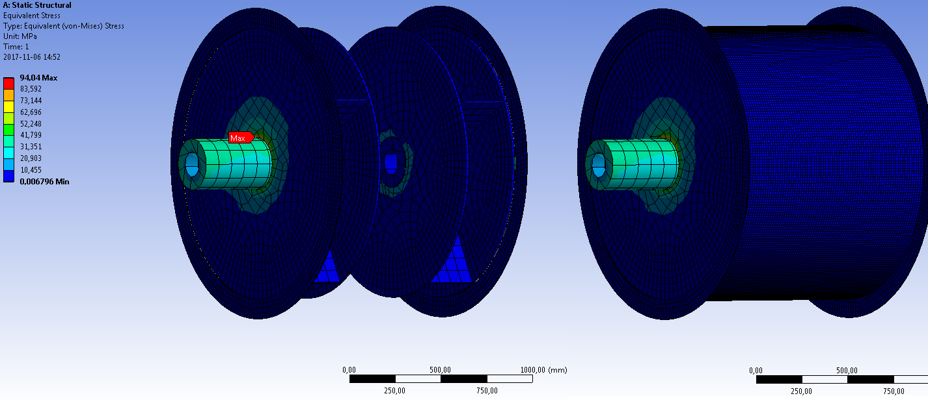

In this calculation a radial force of 200 kN and a torsional moment of 150 kNm was applied. And as can be seen in the figure above next to the inner welds the maximum stress is measured to 94 MPa which is about 14% of the yield strength of duplex steel.

# Analytical model

This section details the analytical modelling for the entire winch system which in other words provides the final dimensions and specifications of the chain link, winch drum and assembly configuration as a whole. Developing analytical model for the final solution or concept is the most challenging and demanding part of the project since there are too many variables and interdependencies which drive the design of the system.

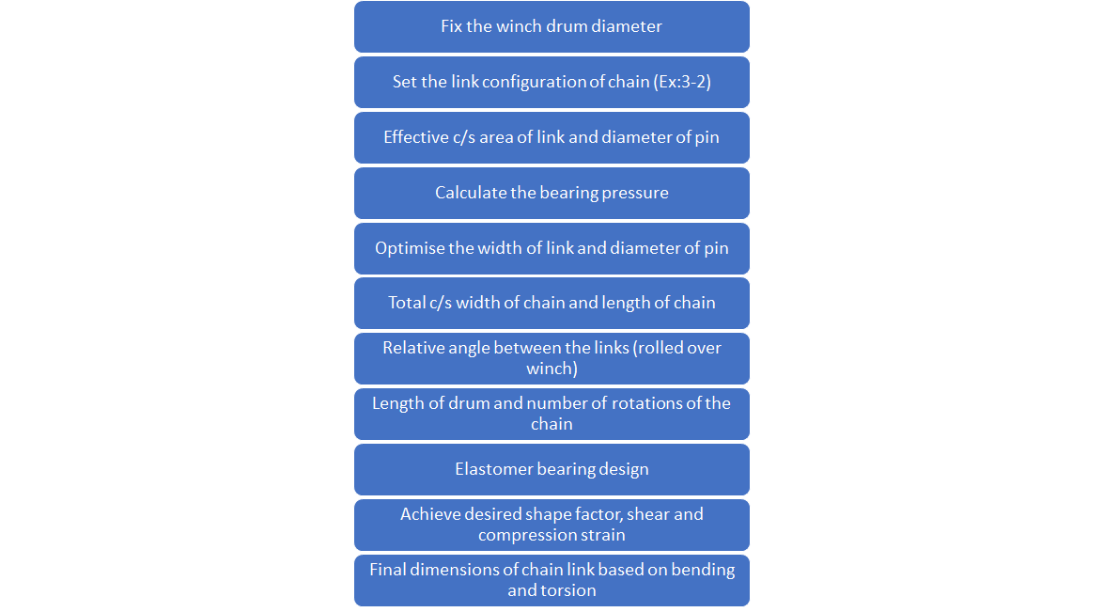

* To begin with, the winch drum diameter is set based on empirical evaluation of torque in the drum, number of links and total length of drum that would be required to accommodate a chain of 30m length. However, this is optimised at a later stage as this is an iterative process based on dimensions obtained for other components.
* The second step is to decide the link configuration in the chain i.e whether the chain would be made of 1-2 , 2-3 or 3-4 link combination to form a segment of the chain. This is a very important step as it determines how the total load in the chain would be distributed per link.
* Assuming a suitable material properties and safety factor for the chain link, the effective cross sectional area required to withstand the tensile load in chain is calculated. Also, the diameter of the pin is determined based on shear strength calculations.
* Taking the bearing pressure into consideration, the final dimensions for width of the links and diameter of the pin is computed by running an optimisation loop satisfying the necessary constraints.
* The total cross sectional width of the chain (3+2) is then calculated with a nominal clearance between the links.
* With the objective of keeping a small relative angle between the links and also having lesser number of links per turn when the chain is wound over the winch drum, the total length of the winch drum and number of turns required is determined.
* The design of elastomeric bearing is explained in the section xxxxx. The bearing dimension is calculated such that desired compressive and shear strain is achieved by varying the shape factor of the elastomeric bearing.
* As the final step the height of the link is computed by taking bending and torsion of the link into consideration.

**Matlab Results**

**For a drum dia of 1.5 m**

**Pin and link dimensions**

The outer dia of pin is 40.6331 mm

The inner dia of pin is 33.4744 mm

Width of the link 1 is 40.6692 mm

Width of the link 2 is 33.9128 mm

Width of the chain is 195.0766 mm

Effective c/s height of the link 5.1226 mm

Clearance b/w each windings 30 mm

Length of the drum is 1.718 m

**Assuming the links to be sides of a regular polygon which circumscribes the circle**

No. of rotations on the drum : 6.3662

No. of links in one rotation : 18

Relative angle between the links : 20 deg

Length of each link : 260.4723 mm

**Stress and Strain calculations for the Elastomeric bearing**

Shape factor of the Elastomers is: 7.9071 and 7.0493

Radial Strain in the Elastomer bearing for max load : 9.9205 and 9.9402

Angular deflection for Elastomer bearing : 5 deg

Resistive torque generated in the Elastomer bearings : 121.5346 and 101.344 Nm

# Finite Element Analysis

The following section describes the finite element analysis of the the chain link. The FE analysis is carried out in ANSYS Workbench 18.1. This section also provides information on the loads and boundary conditions used to perform the analysis, followed by setup of the FE model in the software. Solutions of interest such as stress, deformation etc are captured and inferences are made from these results.

# **Loads and boundary conditions**

Firstly, it is important to understand the type of loading that chain is subjected to while being rolled in and out from the winch as the buoy moves up and down with the heaving motion of the waves. Basically, the links of the chain are subjected to tensile loading during both roll out and roll in phases of operation however the magnitude of the force differs. The chain is expected withstand forces up to 200 kN which is the worst case scenario and hence the design is analysed for the worst case loading to meet this requirement.

Load case 1: Axial loading of the link (when chain is vertical)

Load case 2: Angular load (When chain rolled over drum)

## FEA results for chain link

**Load Case 1: Stress plot**

* Max loading case (1/8 Model)
* Material: stainless steel duplex AISI 2205
* Material Yield strength: 500 Mpa
* Max load applied : 25kN

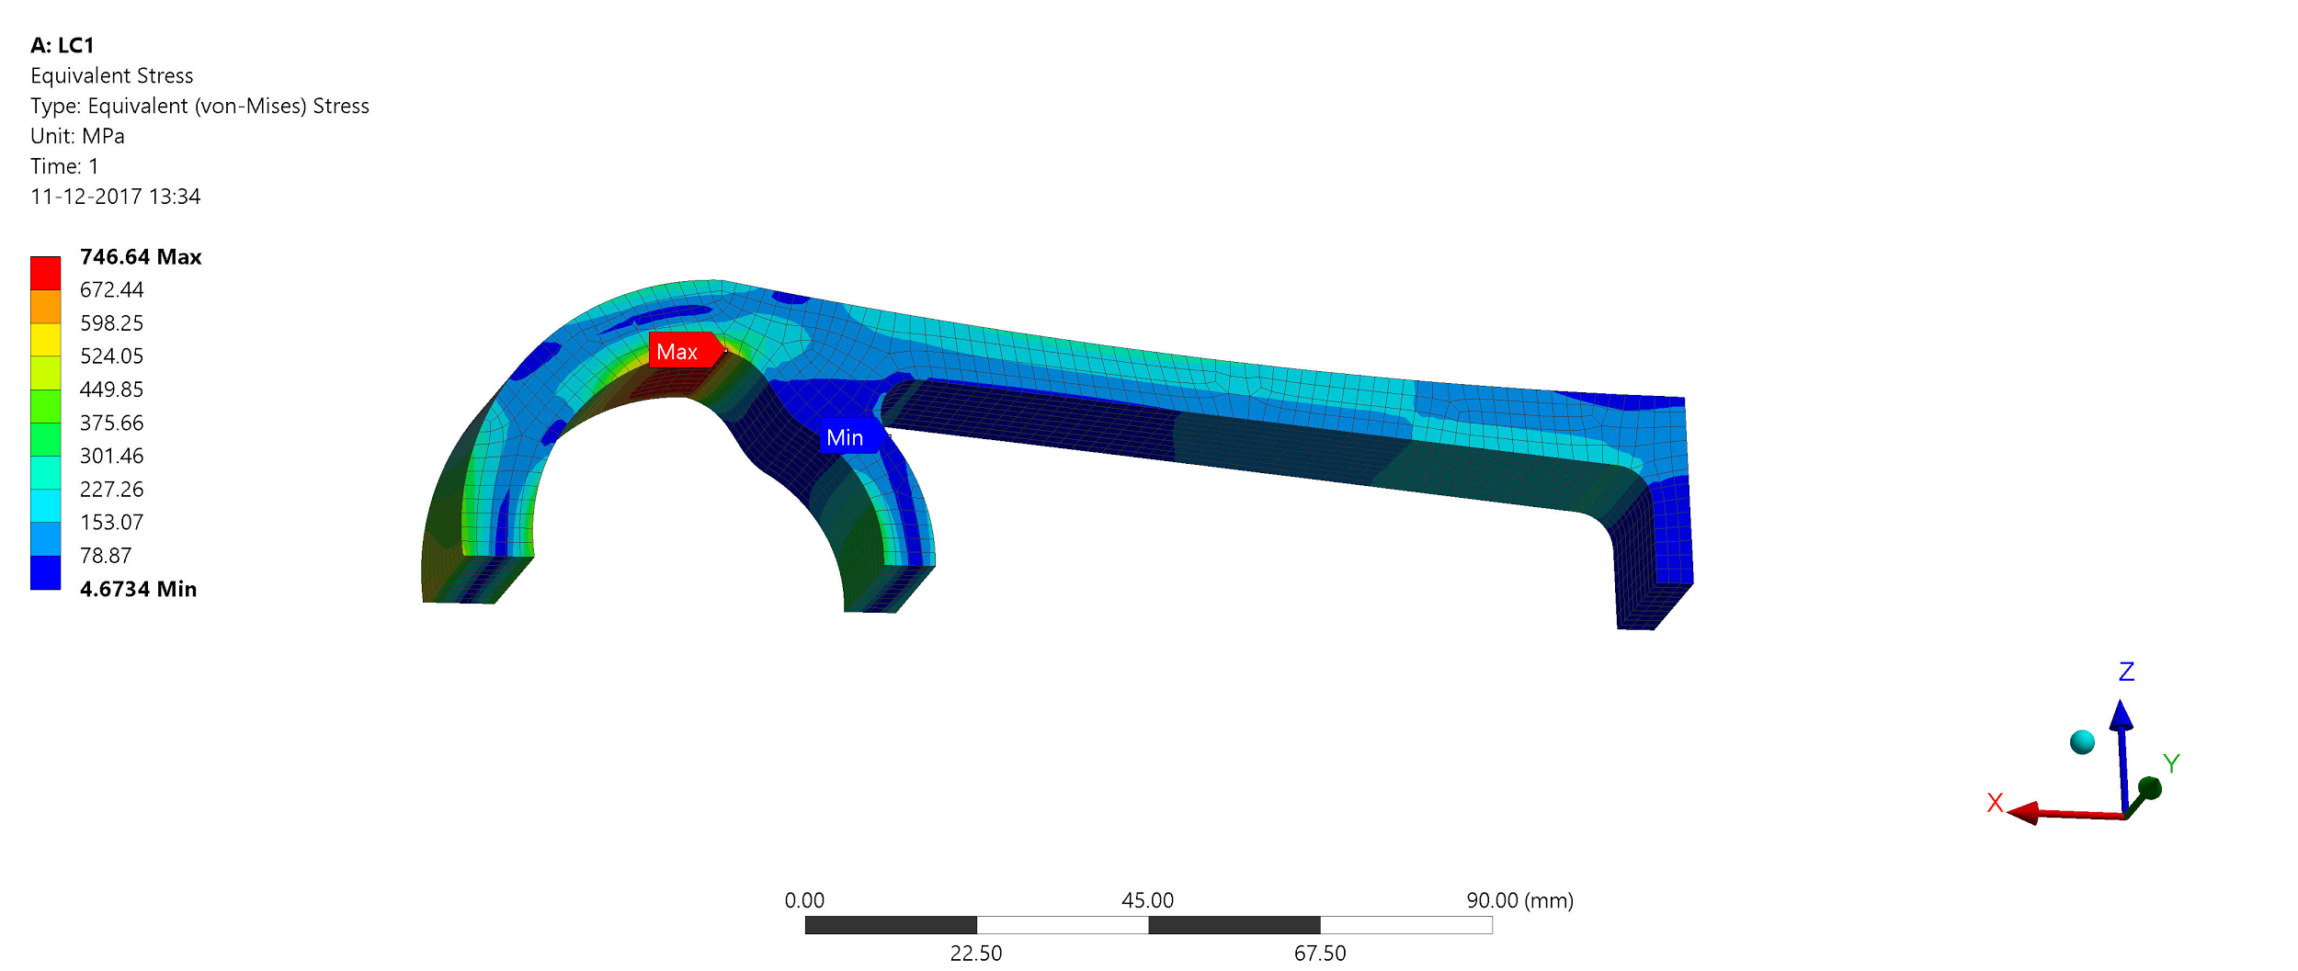

The max von-Mises stress in the link is 746 MPa. This is a local stress concentration due to to abrupt geometry change. However, the max nominal stress in the link is around 300-350 MPa. This value of stress is well under the yield strength of the material which is 500 MPa. The stress concentration can be ignored and this is explained in section (Mesh convergence study).

**Load case 1: Deformation plot**

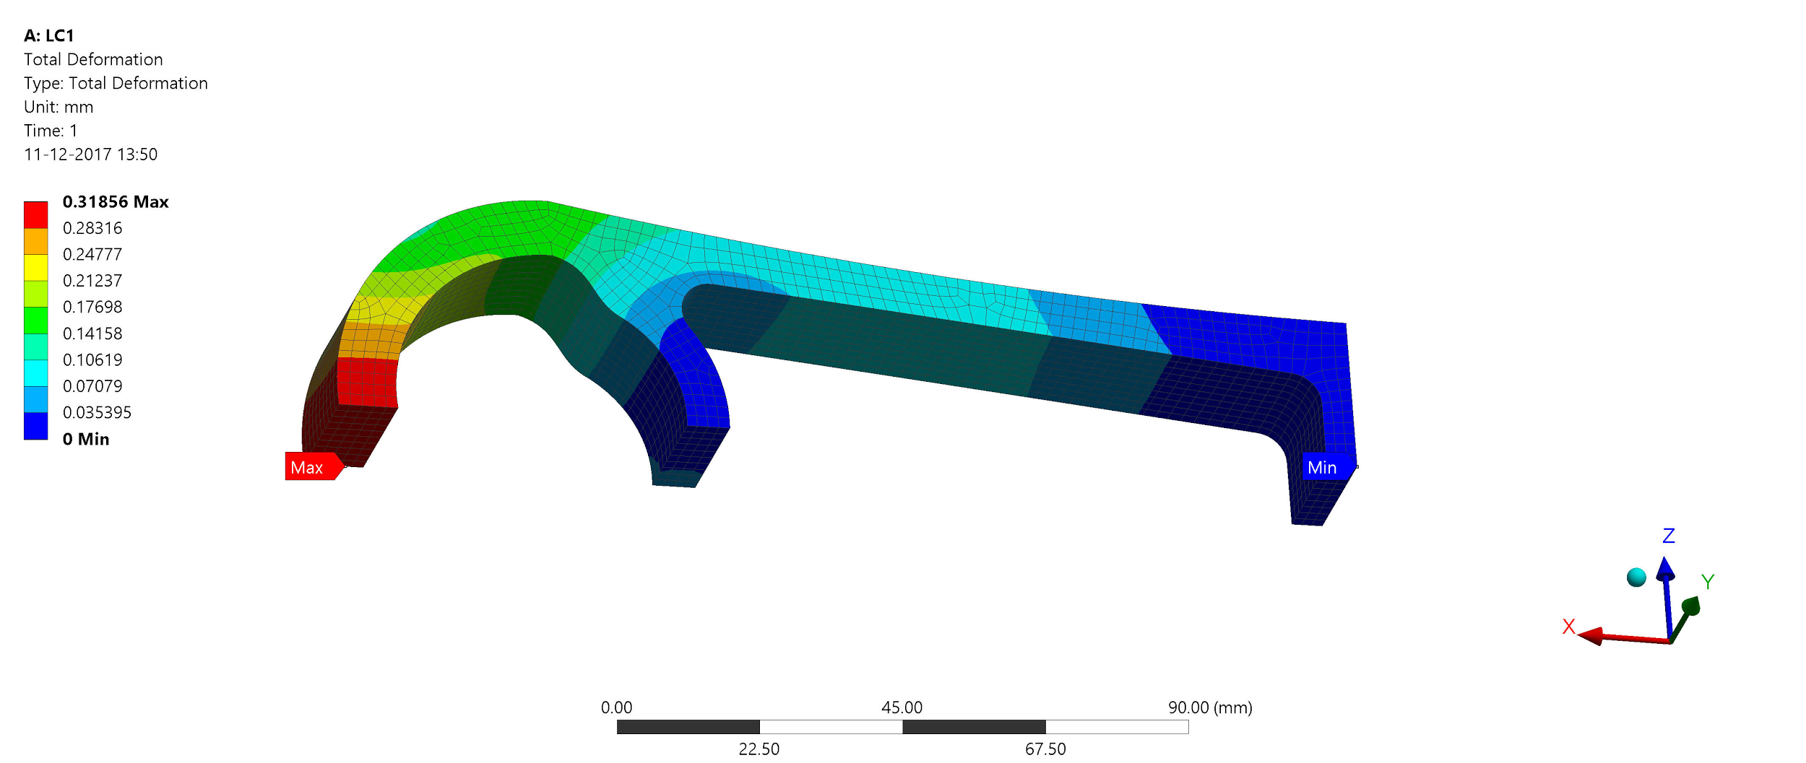

The max deformation in the link is 0.318mm

**Load case 2:**

Max loading case (1/2 Model)

Material: stainless steel duplex AISI 2205

Material Yield strength: 500 Mpa

Max load applied : 100kN

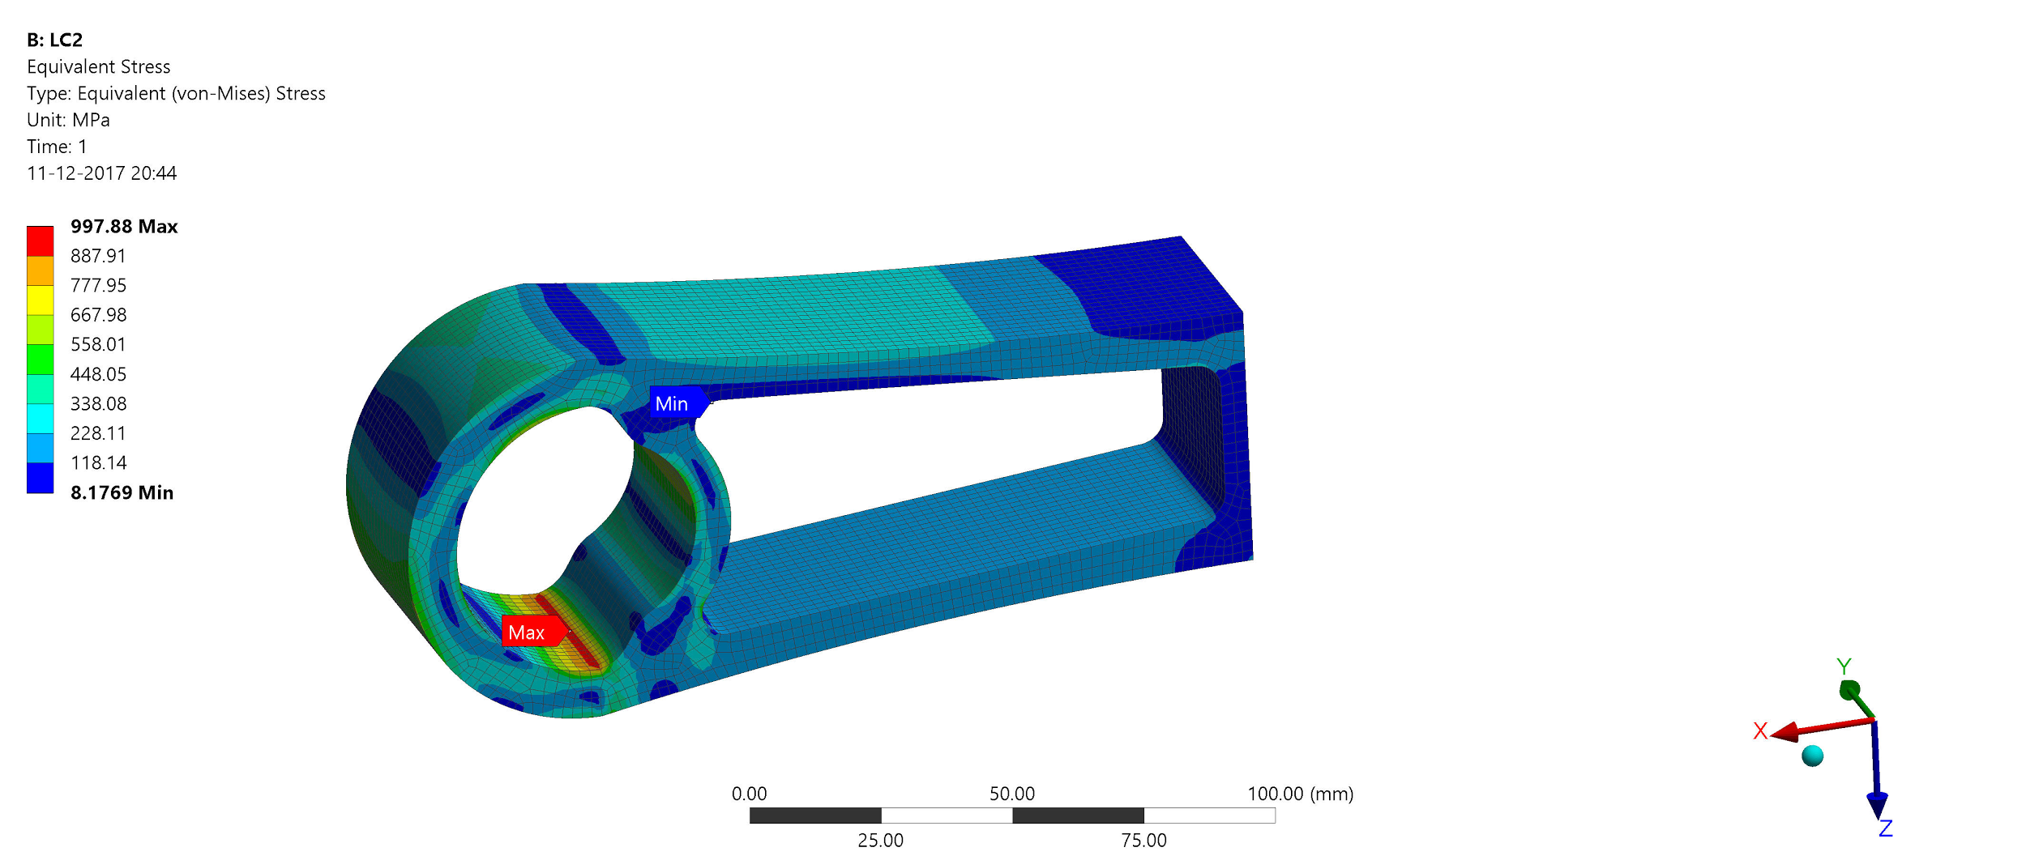

The max von-Mises stress in the link is 997 MPa. This is a local stress concentration due to to abrupt geometry change. However, the max nominal stress in the link is around 300-350 MPa. This value of stress is well under the yield strength of the material which is 500 MPa. The stress concentration can be ignored and this is explained in section (Mesh convergence study).

**Load case 2: Deformation plot**

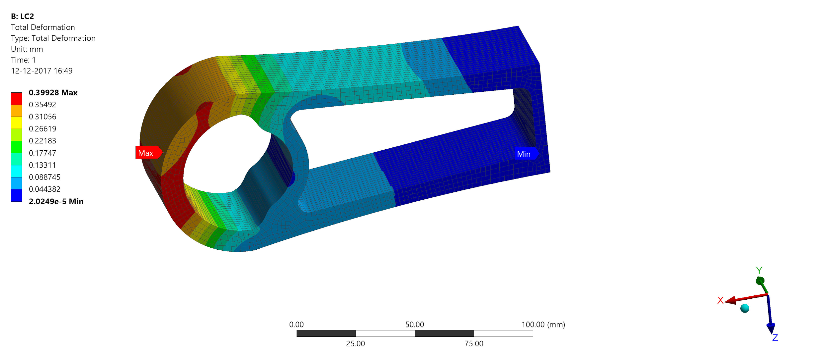

The max deformation in the link is 0.399mm

## Mesh convergence study

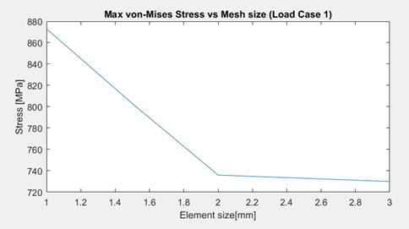

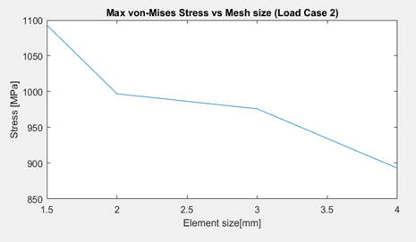

The above fig XX and fig XX shows the mesh convergence plot for load case 1 and load case 2. A coarser mesh is applied in the beginning and refined in steps. It can be observed that the max von-Mises stress do not converge. This region is a point of singularity. A stress singularity is a region of the mesh where the stress does not convergence towards a specific value. As the mesh is refined further, the stress at this point keeps increasing. However, the displacements are correct even at the singularity point. It is to be noted that the overall nominal stress in the link do not change with mesh refinement and this is an immediate consequence of St. Venant’s Principle. Since, the max nominal stress in the link for both load cases is 300-350 MPa which is well below yield strength (500 MPa), it can be concluded that the link will not fail under max load condition.

**Preliminary Pin Model**

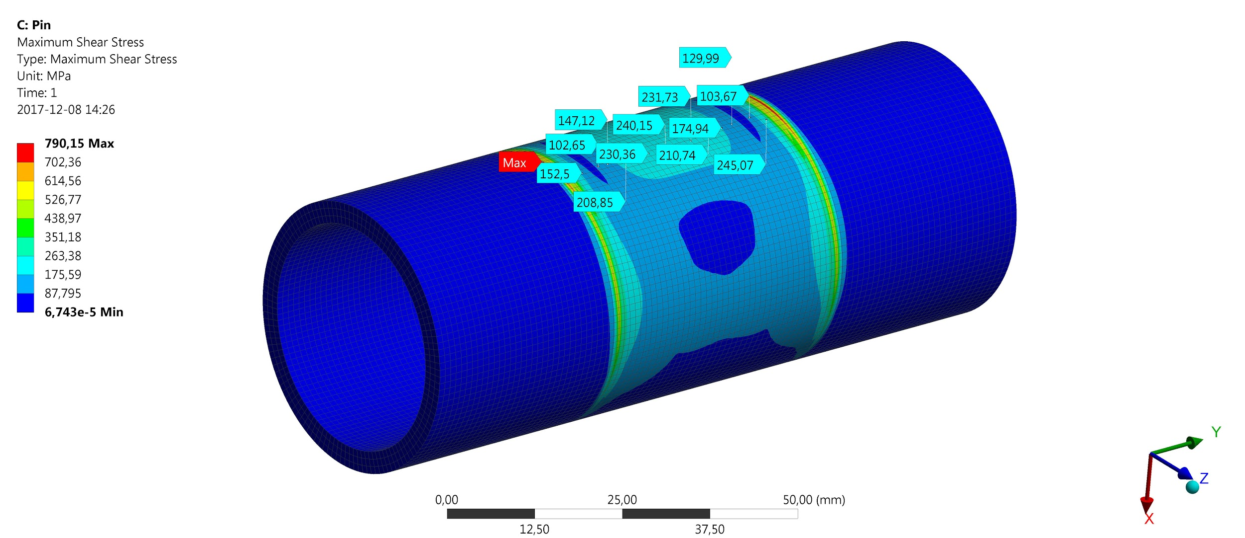

# Fatigue and Life prediction

## Fatigue life assessment of the link

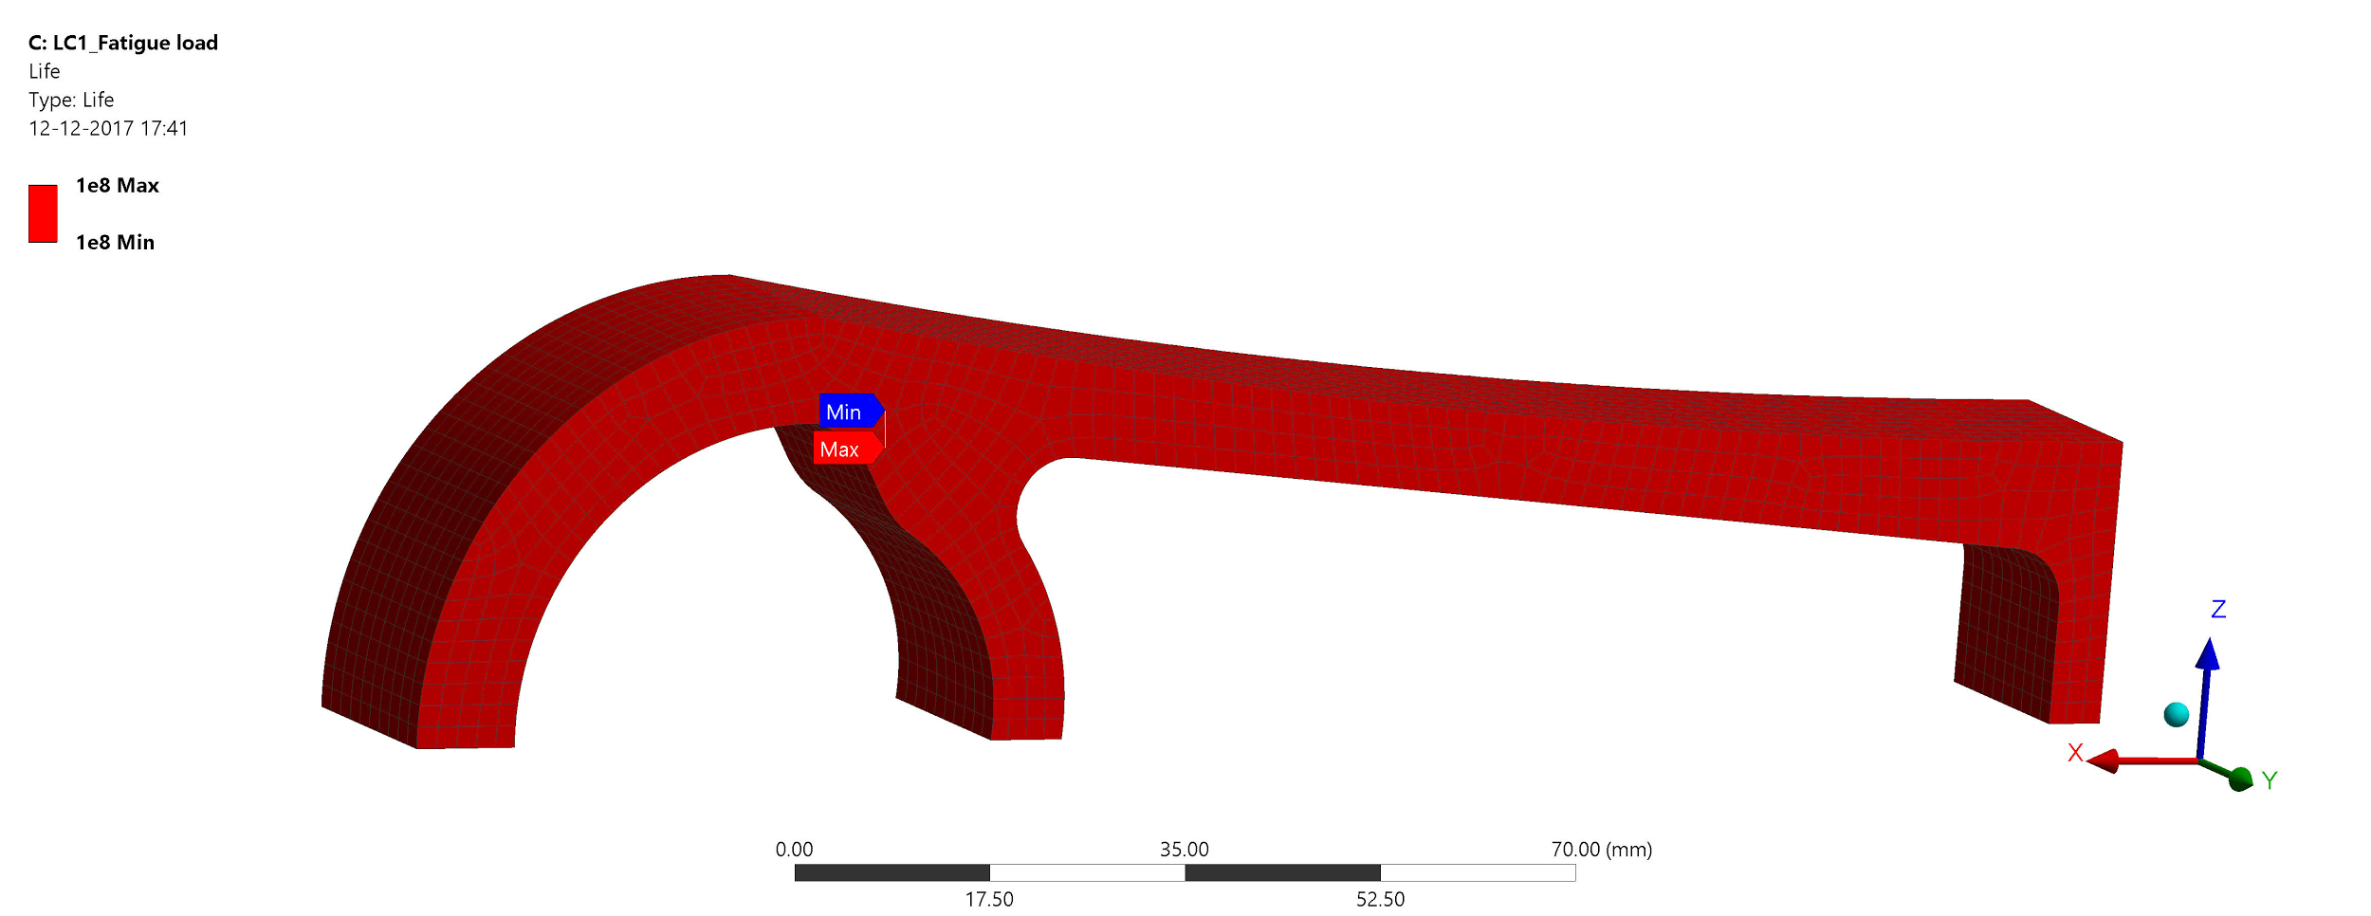

Due to the requirement set out for the winch, the chain link is required to withstand 80 million load cycles or survive for approx 20 years. This is a very crucial requirement for the system as it affects the life cycle cost of the system. A fatigue life analysis is carried out for the link to estimate the minimum life.

Following are the details of the fatigue model used for the assessment:

* Fatigue loading case (1/8 Model)
* Loading input: Bearing load of 10kN
* R-ratio=0,5

i.e Load varies from 10 kN to 20 kN.

* SN curve characteristics of stainless steel duplex AISI 2205

Load ratio of 0.5 corresponds

From the fig xx it can be seen that the mi

## Durability of Elastomeric Bearing

The durability of elastomeric bearing is mainly dependent on how fast the properties of the elastomer degrade. A literature survey was carried out to determine the failure modes and to know more about how properties degrade over time. Significant failure modes of elastomer were identified to be crack initiation due to ozone attack or oxidation of elastomer layer and moisture absorption which will affect the elasticity of the

# Prototyping

**Elastomeric bearing**

Securing the rubber laminates to the reinforcing steel shims was done with autoclaving. The steel shim and the fixtures are made of standard steel and aluminum pipes respectively, that were cut in half normal to the cross-sections plane.

The steel shim is firstly cleaned, ensuring the surface is free from particles that can intervene with the vulcanization. A bonding liquid is then applied to the outer and inner part of the shim. The rubber is placed on a fixture made in aluminum, with an outer radius equivalent to the pin radius (see figure x), the shim is then placed on this rubber laminate. Lastly, the second and last rubber laminate is placed on the shim, and a second aluminum fixture with the inner radius equivalent to the outer radius of the lastly placed rubber laminate is fixed. High pressure steam is then pumped into a vessel where the rubber layers react with the bonding liquid due to the high temperature. This procedure causes the rubber laminates to be vulcanized on the steel shim.

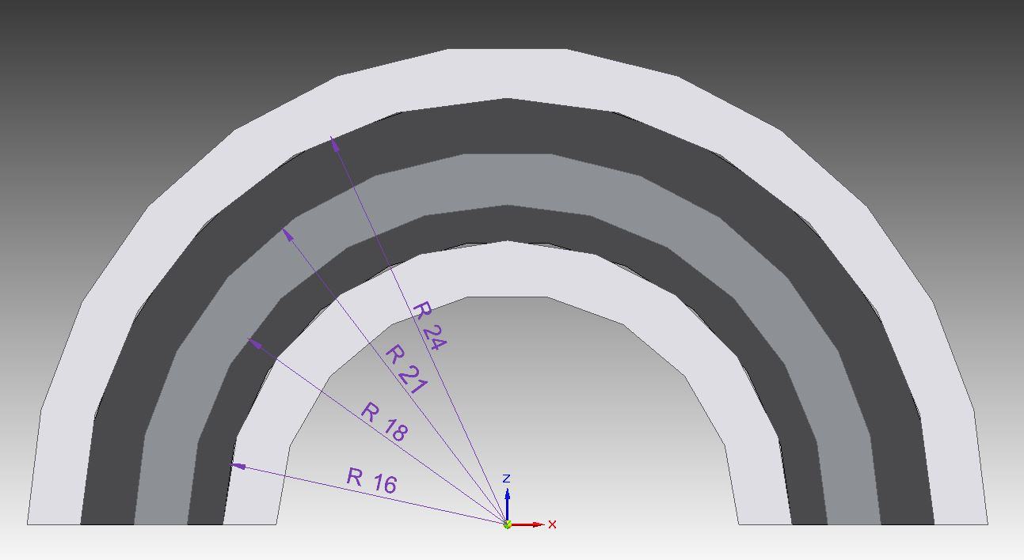

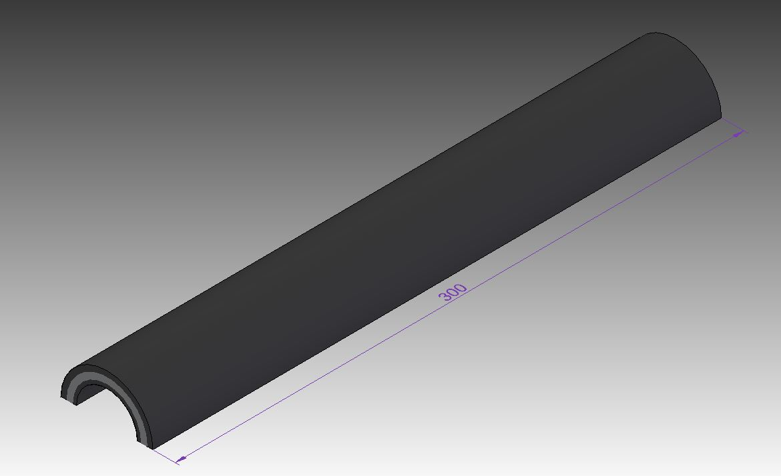

The bearing was made in a 300 mm length, solely for simplification in terms of manufacturing. A 30 mm part of the length was then cut to obtain the bearing for the prototype link.

**Link**

Weldox 900 steel plate was water jet cutted. The hole dimensions were cut with a radius 1 mm smaller, so the last mm could be milled in order to achieve the best possible fit for the bearing.

The elastomeric bearing was glued to the link and pin with Loctite 638. The milling provided a good surface for the glue to adhere.

**Test rig**

It was decided to test the elastomeric bearing for shear and compression deformation experimentally and correlate the results with the analytical model. In order to achieve this, a test rig was conceptualised and built. The main purpose of the test rig is to shear the rubber in the elastomeric bearing while the link is tensioned. This replicates the real scenario where the chain is wound around the winch drum. The links would be bent at an angle relative to one another and at the same time the mooring forces would tension the links. However, the elastomeric bearing in both ends of a link would be subjected to compression .

The below figure XX depicts the concept for test rig.

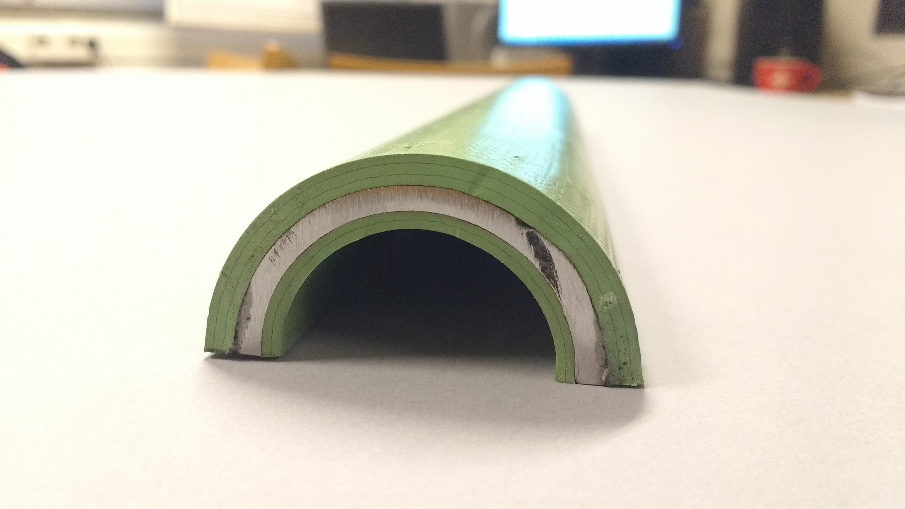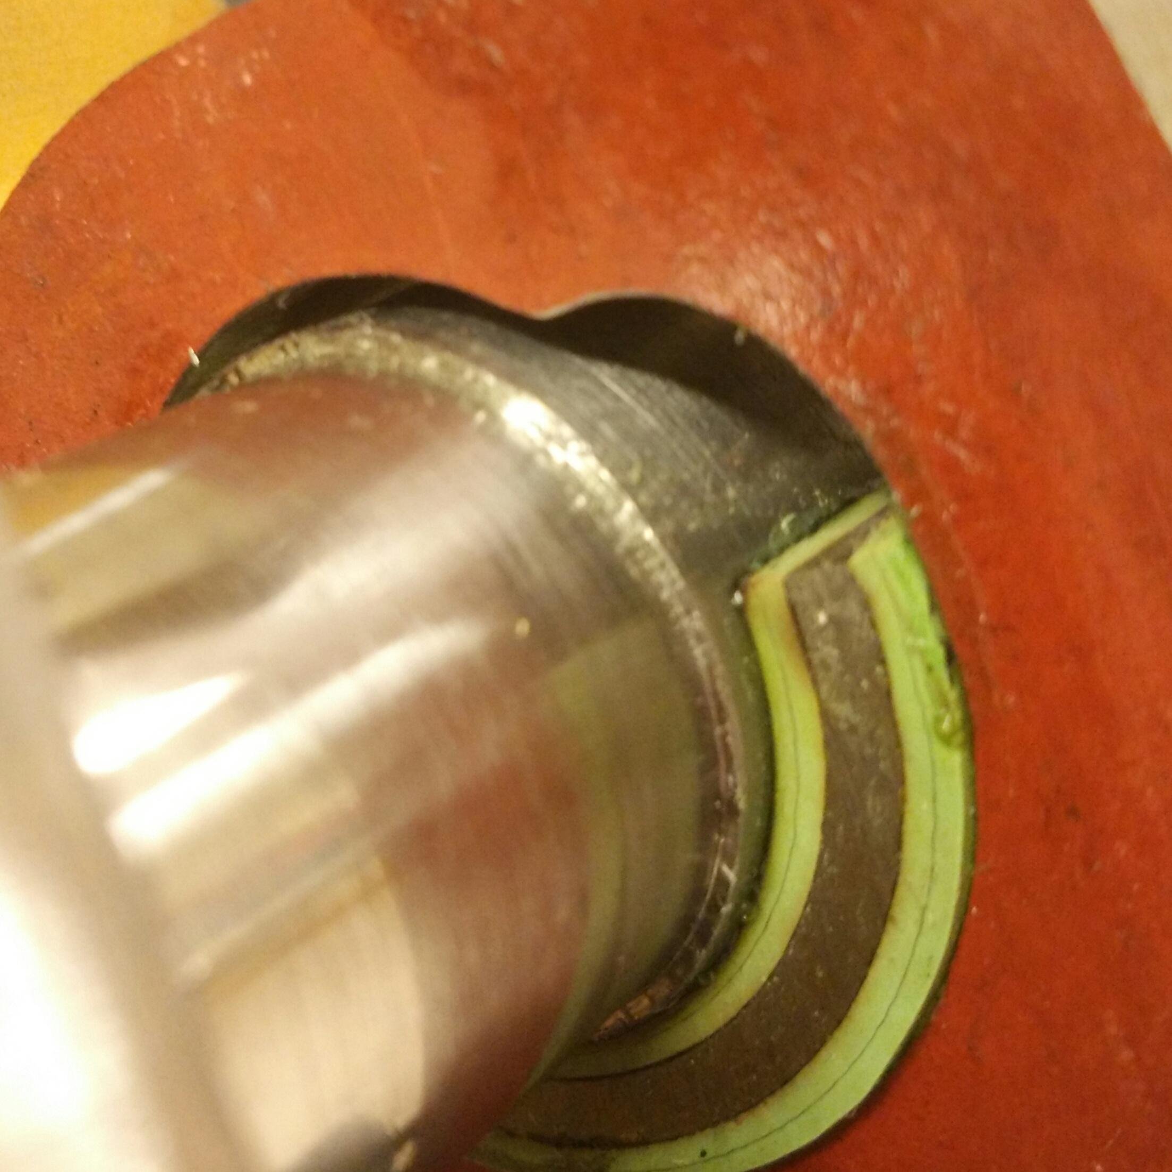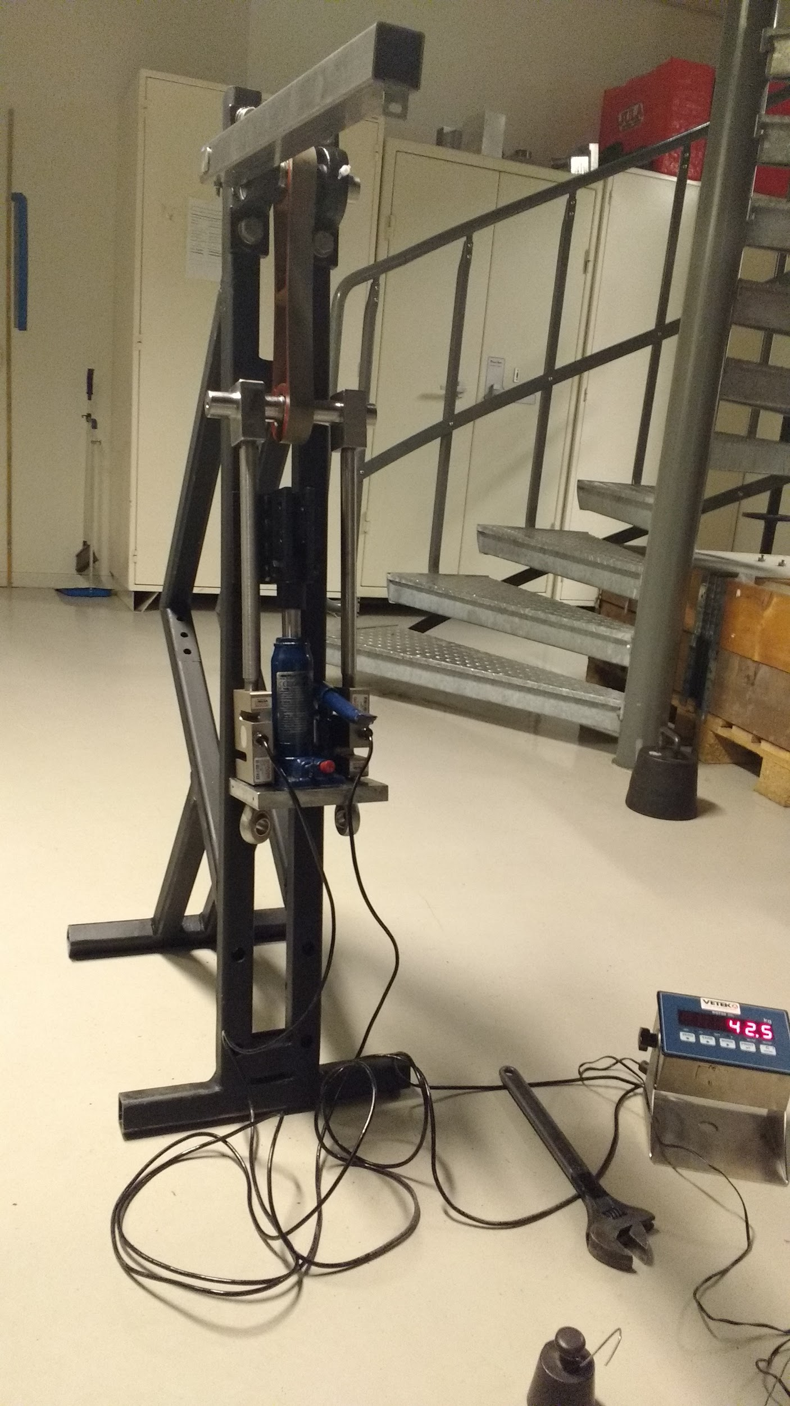

As illustrated in the figure XX, the test rig comprises of only one link manufactured to full scale. Two rail guide beams form the base of the test tig setup which is positioned vertically with necessary support. Suitable bearings matching the pin diameter are selected and the bearing housing is mounted at the top end of the rail guide beams. The pin is made slightly longer with a slot cut on the end to secure a lever arm. The purpose of the lever arm is to provide the necessary force to produce shear deformation in the elastomeric bearing. A support block is mounted below the bottom end of the link. This block is bolted firmly on the rail beams. A hydraulic jack is used as it is a simple way of providing the necessary tension force in the link. The Fig XX shows the hydraulic jack and supporting attachments arrangement. Load cells are used to measure the force being applied. When the hydraulic jack is actuated, the piston from the jack pushes against the fixed solid support clamp. This in turn

## Test Procedure

Below is the test procedure for the elastomer bearing with the link:

* The test rig is set up as as explained in the previous section. Necessary checks are made to ensure that there are no loose connections or joints.
* The dead weights required for providing the torque are kept ready i,e 1kg and 10 kg weights.
* Laser pointer and the dial gauge is set to zero reading.
* The hydraulic jack is loaded in steps as shown in the below table which provides the compression load on the elastomer bearing.
* For every compression load value, the lever arm is loaded with dead weights of 1 kg and 10kg. This provides the torque to shear the elastomer bearing.
* For every load case, radial deformation and the deflection in the laser pointer is recorded.
* This experiment is repeated to confirm the results.

|  |  |  |  |  |
| --- | --- | --- | --- | --- |
| **Test number** | **Compression load [kg]** | **Lever arm load [kg]** | **Radial deformation (mm)** | **Deflection reading (mm)** |
| 1 | 150 | 1 |  |  |
| 2 | 10 |  |  |
| 3 | 5000 | 1 |  |  |
| 4 | 10 |  |  |
| 5 | 7500 | 1 |  |  |
| 6 | 10 |  |  |
| 7 | 10000 | 1 |  |  |
| 8 | 10 |  |  |
| 9 | 13420 | 1 |  |  |
| 10 | 10 |  |  |

## Experiment results

The table below gives the results of the experiment carried out. As highlighted in the test procedure, the radial deformation and deflection reading of the laser are captured. Shear deformation in the elastomeric bearing is then calculated based on the distance of the laser from the wall.

|  |  |  |  |  |  |  |
| --- | --- | --- | --- | --- | --- | --- |
| **Experiment Results** | | | | | | |
| **Compression load (kg)** | **Compression load (N)** | **Lever arm load (kg)** | **Torque applied (Nm)** | **Radial deformation (mm)** | **Deflection reading (mm)** | **Shear deformation (Deg)** |
| 150 | 1500 | 1 | 5 | 0.12 | 60 | 0.85 |
| 10 | 50 | 0.12 | 740 | 10.48 |
| 500 | 5000 | 1 | 5 | 0.4 | 65 | 0.93 |
| 10 | 50 | 0.36 | 740 | 10.48 |
| 750 | 7500 | 1 | 5 | 0.52 | 50 | 0.71 |
| 10 | 50 | 0.5 | 690 | 9.79 |
| 1000 | 10000 | 1 | 5 | 0.87 | 45 | 0.64 |
| 10 | 50 | 0.87 | 670 | 9.5 |
| 1342 | 13420 | 1 | 5 | 0.88 | 50 | 0.71 |
| 10 | 50 | 0.84 | 650 | 9.23 |

In the following section, the above results are analysed and discussed.

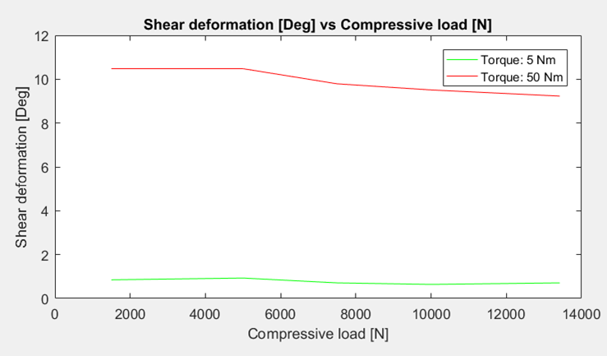

The fig xx shows the variation of shear deformation in the elastomer bearing for two torque values as function of compressive load. The

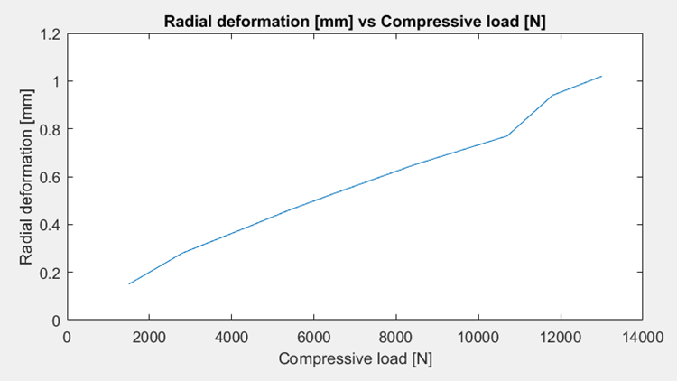

## Correlating experiment and analytical model

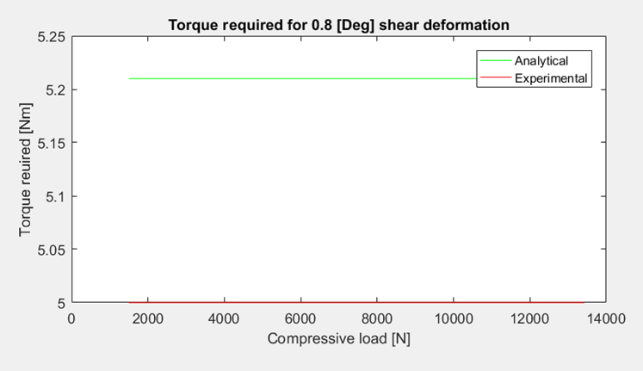

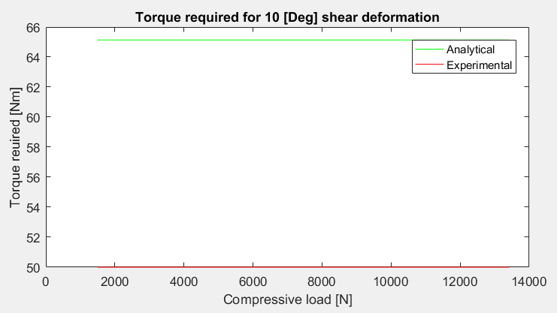

# Conclusions and discussion

The number of laminates in the prototype are less than in the final design. The pipes that would be needed to cut the half cylindrical shapes are not of standard dimensions, thus they were not available at KTH and the delivery time from manufacturers were not in accordance with the project plan. It should be noted that the pipes will deform slightly when cut and that the pipes are not of uniform thickness. Because of this, wire EDM was looked into as an option, but it was deemed too costly and the delivery time was also an issue.

If the final design of the bearing is to be prototyped in the future, wire EDM is viable in the sense that very good tolerances will be achieved and the half cylindrical shapes will be of uniform thickness. The elastomeric bearing should also be vulcanized to the pin and link rather than glued, to achieve best possible shear strength in the bond.

# Future Work

Further development and analysis should be performed on the proposed concepts for the winch alignment system in order to investigate their feasibility.

Fatigue testing should be performed on the link with the elastomeric bearing. Utilizing the current test rig, a motor could be attached to the pin. The motor can achieve rotational oscillation so the winding/unwinding of the chain on the drum could be tested for a large amount of load cycles.

**References**

**Appendix**